Easy to read

A report about what children and young people around the world think of their care if they do not live with their parents

The care they get is called Alternative Care

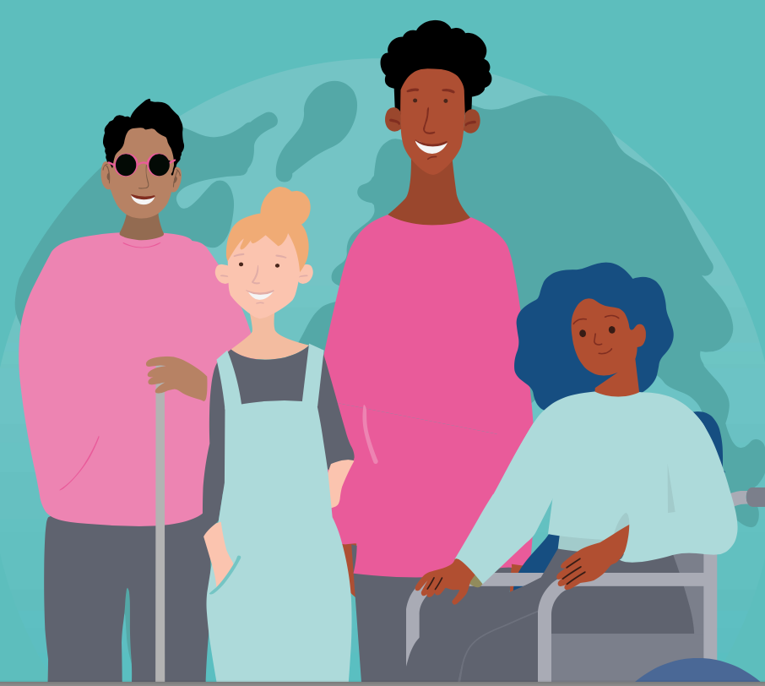
Make Our Voices Count. September 2021.
Original report by Kate Butler, Vanessa Currie Katie Reid and Laura Wright from the International Institute for Child Rights and Development.

About this report
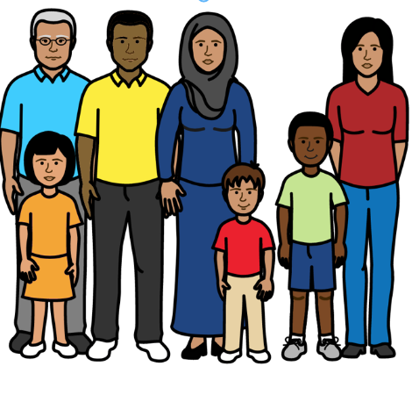

We are a group of people from different countries who do research.

Research is when you look into something to find out more.

Our research group includes children and young people.

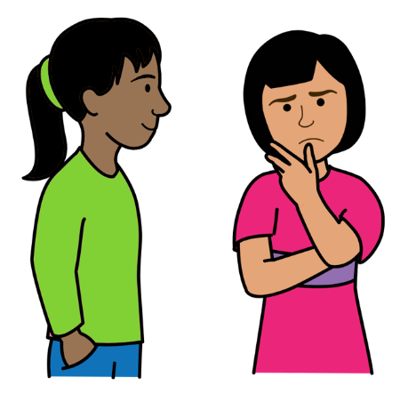

We wanted to find out what children and young people think about their care if they do not live with their parents.

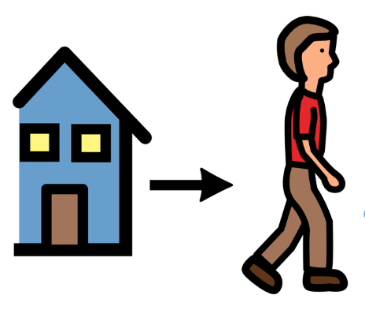

Some children and young people live away from their parents.

For example, because their parents do not get the right support to look after them.

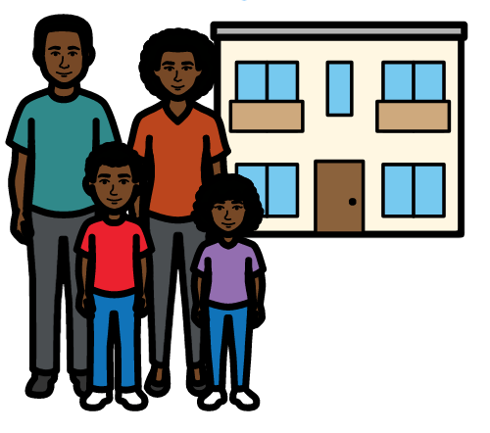
The children and young people live in other places instead.

For example, they might live with other people in their family.

Or they might live in homes for children.

This is called Alternative Care.

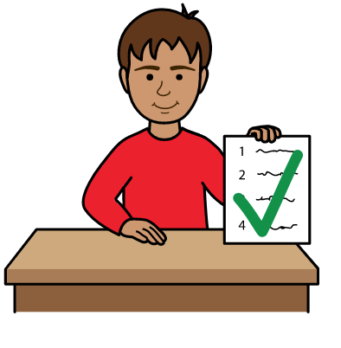

This report is about what children and young people told us about their care and what they want to change.

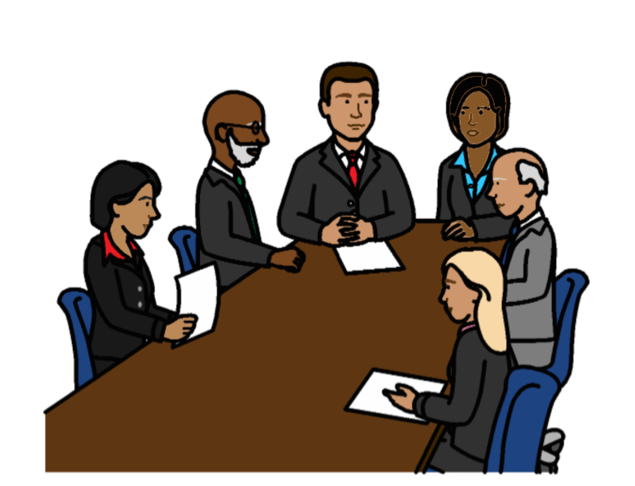

This report is for a meeting in September 2021.

The meeting is about care for children who do not live with their parents.

People from around the world will be at the meeting.

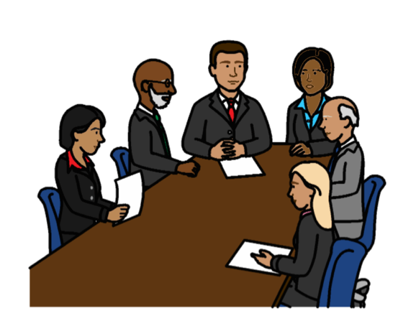
The meeting will be run by a group of people who know a lot about the rights of children.

They are called the UN Committee on the Rights of the Child.

They check that countries are giving children their rights.
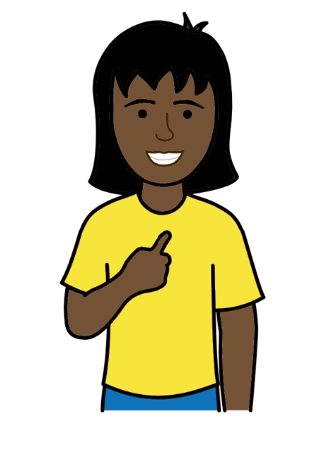

Rights are things that everyone has.

For example, all children have the right to be safe and treated fairly.

But that is not always happening.

There is a document about the rights of all children in the world. Many countries have promised to follow it.

The document is called the Convention on the Rights of the Child.

How we found out what children and young people think

We asked children and young people some questions about their care.

We did this in April and May 2021.
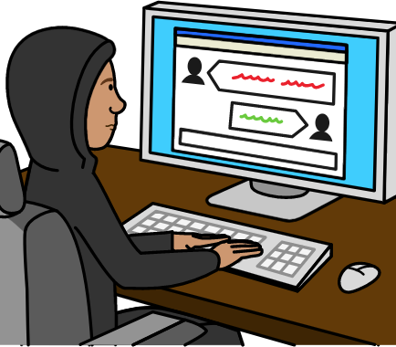

Most children and young people answered the questions on the internet.

They could answer in different languages.

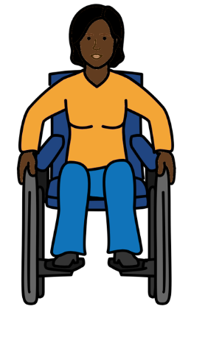
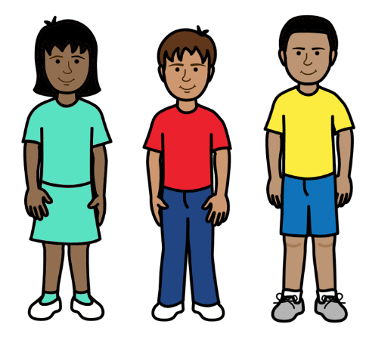

Many children and young people around the world answered the questions.

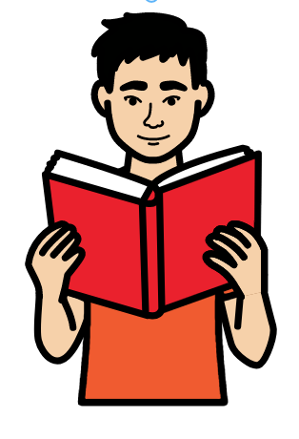
They were between 5 and 25 years old.

Their answers will help people to know what is happening to children and young people and what needs to change.

The main things that children and young people told us
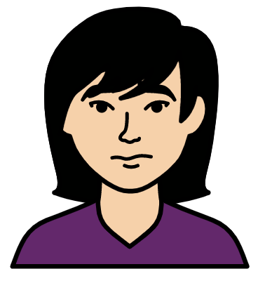

Better support to keep children and young people with their parents if possible

Life is hard for many children and young people who live away from their parents.
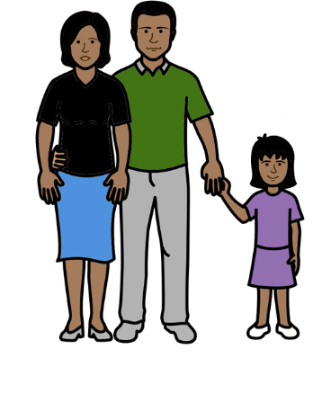

It is best for children and young people to stay with their parents if possible.

Children and young people should only live somewhere else if there is no other choice.
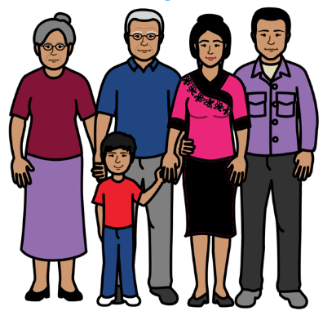

Families should get support to stay together first.

That should happen before children are taken away from them.

The support might be things like:
- Money to buy things they need
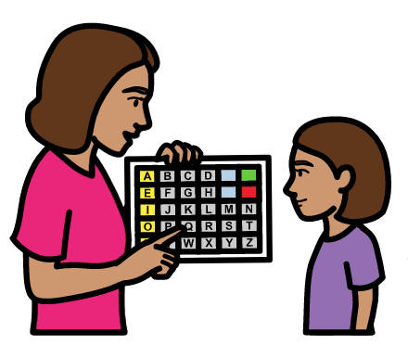
- Free education
- Learning skills to get a job
- Support to be happy and love each other
- Extra support for children with disabilities
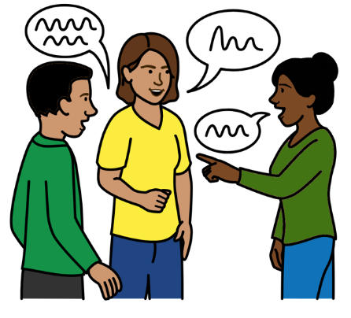

There should be good training and support for parents who need it.

This can help parents to care for their children in the best way.

For example, it can help them to listen to their children and stop using violence.

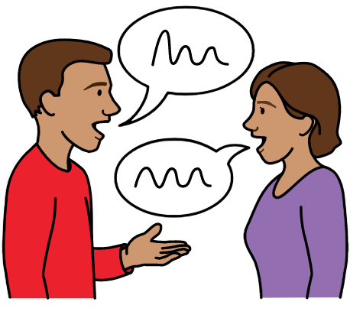

Parents should also get support to feel better if they find things hard.

That includes having a break if they need it.

It should be OK for parents to ask for help.
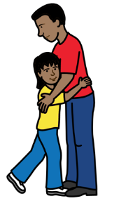
Support like this can help to keep families together.

Children and young people should help decide what the support for parents is like.

Give children and young people better care if they live away from their parents
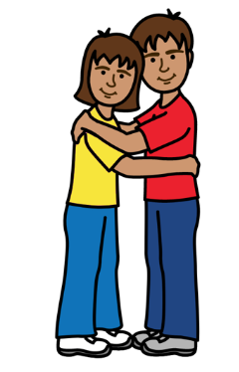

Children and young people told us some things that were important to them.

For example:

Brothers and sisters should stay together if they live away from their parents.
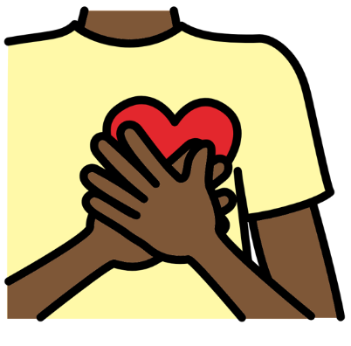

Children and young people want to feel loved and cared for.

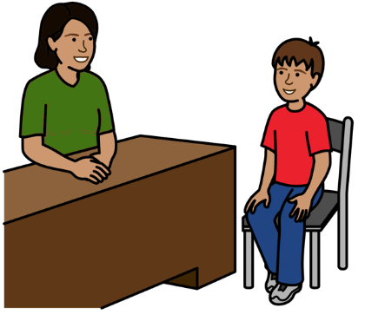
Children and young people want support from the same people all the time if possible.

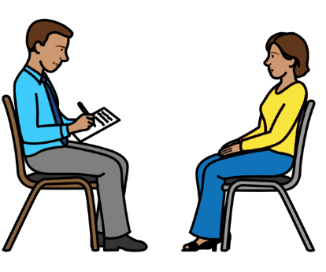

People who care for children and young people should get the support they need to keep working.

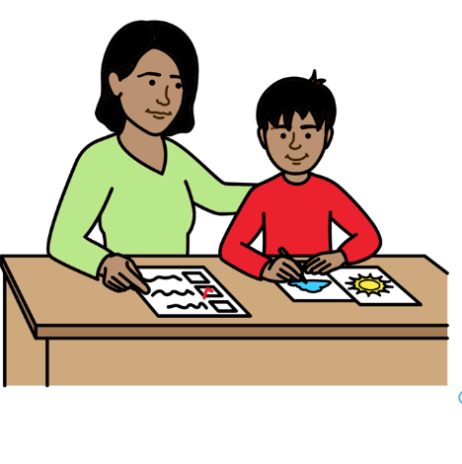

Adults should be kind and spend time with children and young people.

They should get to know them and try to understand them.
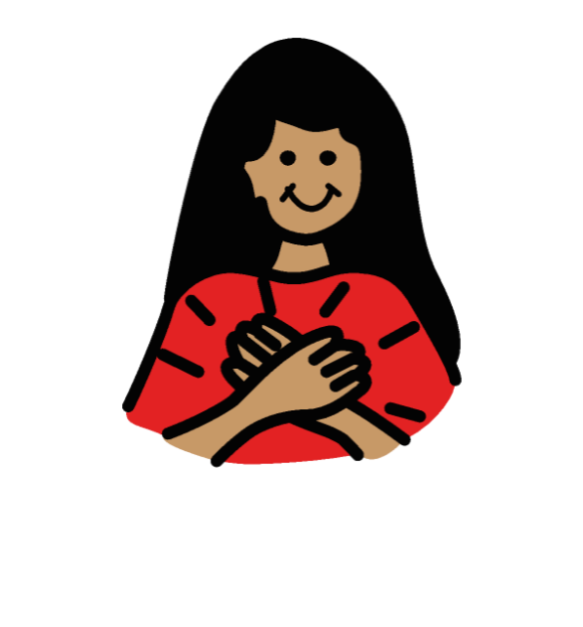

This will help children and young people to trust them.

Children and young people need to be safe from violence and other bad things.

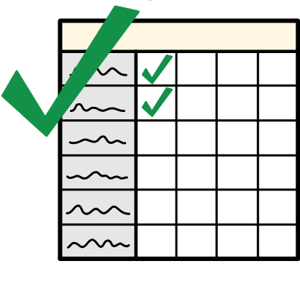
Children and young people should get everything they need to be safe.

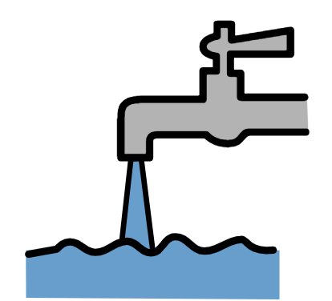
For example:

- Healthy food and clean water

- Health care and education

- Somewhere safe to play
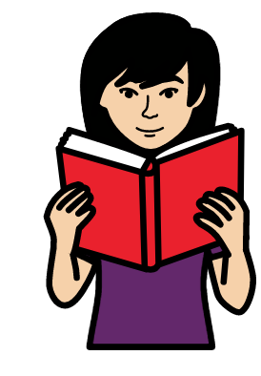

- Someone safe to talk to in private if there is a problem

- Information about their rights

- Good support to feel happy and well

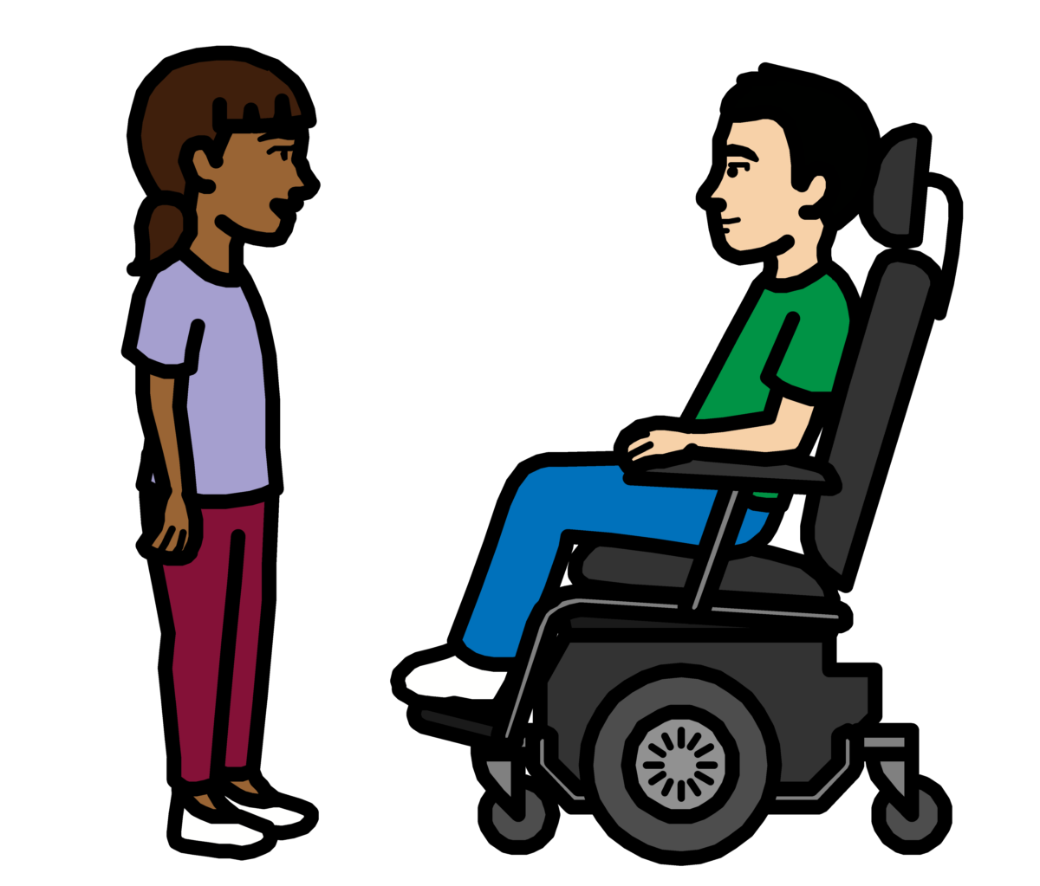

Children and young people also said they need:

- Fun

- Time with their friends

- Time to be alone

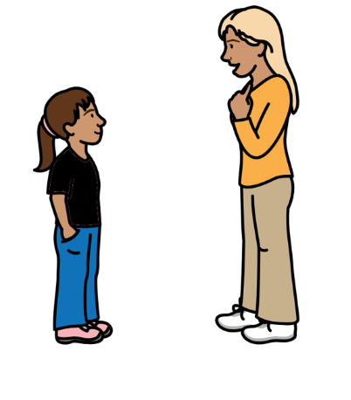
The government should check the care that children and young people get and solve any problems.

They should ask children and young people what they think of their care.

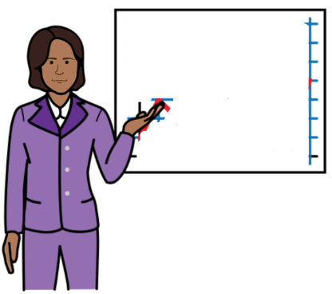
Adults should get training to help stop violence and bad things happening to children and young people.

Adults includes parents, teachers and people who care for children and young people.
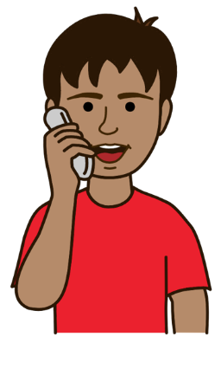

Children and young people should get support to keep in touch with people who are important to them.

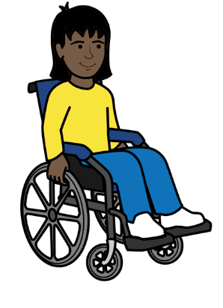

All children and young people who live away from their parents should be treated fairly.

They should get the support they need.

This includes girls and children with disabilities.
Children and young people should get support to be who they want to be.

This includes support to do with:
- Their culture. Their culture is about things like their language, religion and where their family are from
- Who they are and who they might want relationships with
- Their life in the past before they left their parents
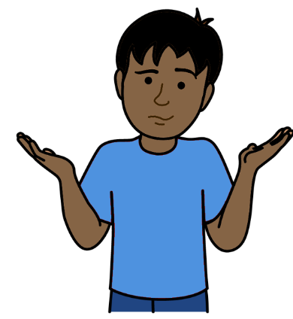

Listen to children and young people

Adults often leave children and young people out when they make plans and decisions about them.

That needs to change.
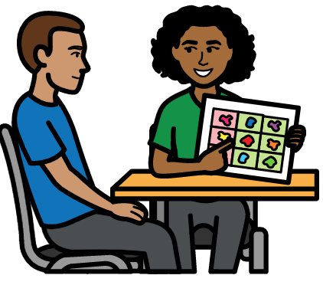

Children and young people have the right to speak up and have their say about the care they need.
They should get the support they need to have their say
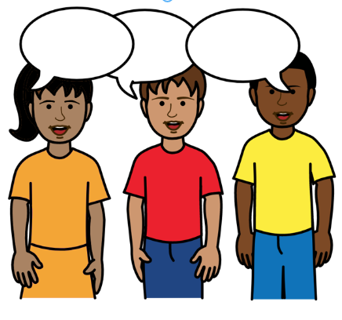
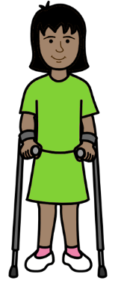
Adults should get training about how to listen to children and young people and make sure they have a real say.

Children and young people should help with the training.

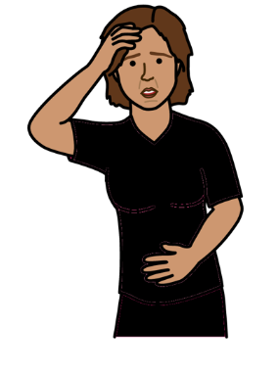

Better support during Covid-19

Adults should ask children and young people what they need because of Covid-19.

Covid-19 is an illness that many people in the world have been getting.

Covid-19 has made life very hard for many children and young people that we heard from.

For example, many children and young people could not see friends or family or go to school during Covid-19.

That made many children and young people lonely, worried or sad.
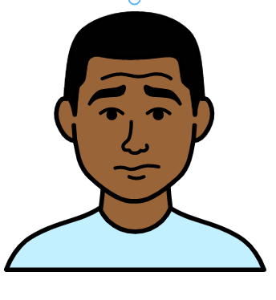
Better support for children and young people when they leave care

Leaving care can be hard for children and young people.

This includes when they leave one place to get care somewhere else.
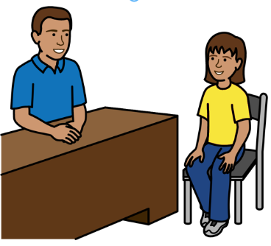

Children and young people should get the right support after they leave care.

The support should not just stop.

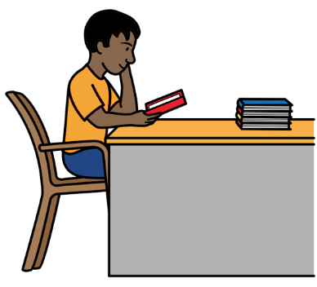

They might need support with many things.

For example:
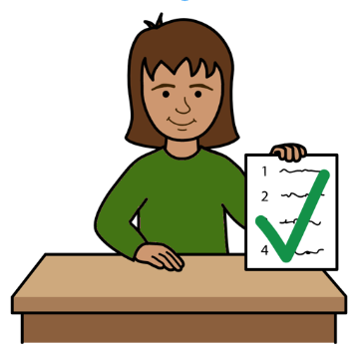
- Support to feel OK
- Support with money, education and jobs

All of these things will help children and young people to get their rights.
Pictures apart from the front cover by The Picture Communication Symbols ©1981–2016 by Mayer-Johnson LLC a Tobii Dynavox company. All Rights Reserved Worldwide. Thousands of resources available for free at www.boardmakeronline.com © European Easy-to-Read Logo: Inclusion Europe. More information at www.easy-to-read.eu.

